RAS TYN-Y-GROES HILL RACE

RAS FYNYDD FELL RACE
Saturday/Sadwrn, June/Mehefin 26^{th/ed} 2010
Start/Cychwyn 12.00 noon Tyn-y-Groes, Ganllwyd, Gwynedd.

O dan reolau WFRA/Run Under WFRA Rules 2.1 miles/milltir, esgyn 700 feet ascent
Yn Gyntaf rhedeg cyn 1925/First run before 1925
Dim wobrau/No prizes
Registration/Cofestru on the day/ar y dydd
Tal/Entry: £3 i achos dda/to charity
Ukraine Humanitarian Aid (childrens cancer hospital)

www.brodysynniac.com www.wfra.org.uk www.tynygroes.com
Trefnwr Bob Chilton onygena@tiscali.co.uk 01341440611

Fastest man and fastest lady to be recorded in Tyn-y-Groes record book and have their names engraved on the shield that will be permanently displayed in the
Tyn-y-Groes Hotel
The original race went in an almost straight line from the Tyn-y-Groes Hotel crossing a bridge (no longer existing) and straight up a steep slope to the summit of Mynydd Penrhos and back again. Tree planting and safety considerations do not permit the use of the old route but the new route preserves the essence of the old .
This race starts from the picnic area and climbs very steeply, levels out for an undulating winding stretch with a slight gain in height to the summit, then declines slowly at first then more steeply before crossing a minor road and finally following the riverbank upstream to the finish on the picnic field. The route is clear, on well marked paths and marshalled.
Running shoes (preferably fell shoes) are recommended. The terrain is slippy and rugged in parts.
This is a category A short fell race and as such we request that you bring your fell kit just in case the weather is severe enough to make it necessary
Minimum age on race day 14 years. Entry limit 150 (don’t worry we won’t make 150)
Celebrations afterwards in the Tyn-y-Groes Hotel
Llawer o Hwyl ar ol ac yn y Gwesty Tyn y Groes

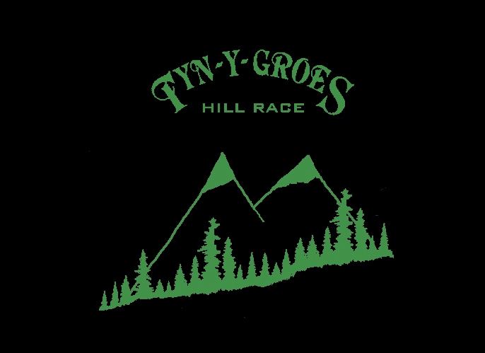
Trefnwr/Organiser Bob Chilton, Hendre Berfedd, Hermon, Dolgellau, Gwynedd LL40 2LW

